Name:Areeb Ansari Roll No:A3-B1-01

Practical 7
Aim: Implement Hamiltonian Cycle using Backtracking.
Problem Statement:
The Smart City Transportation Department is designing a night-patrol route for
security vehicles.
Each area of the city is represented as a vertex in a graph, and a road between two
areas is represented as an edge.
The goal is to find a route that starts from the main headquarters (Area A), visits
each area exactly once, and returns back to the headquarters — forming a
Hamiltonian Cycle.
If such a route is not possible, display a suitable message.
Code:
#include <stdio.h>

#define N 5

int G[N][N] = {
{0, 1, 1, 0, 1},
{1, 0, 1, 1, 0},
{1, 1, 0, 1, 0},
{0, 1, 1, 0, 1},
{1, 0, 0, 1, 0}
};

int path[N];
int used[N] = {0};

void printCycle() {
for (int i = 0; i < N; i++) {
printf("%c ", 'A' + path[i]);
}
printf("%c\n", 'A' + path[0]);
}

void addToPath(int pos) {
if (pos == N) {
if (G[path[pos - 1]][path[0]] == 1) {
printCycle();
}
return;
}

for (int v = 1; v < N; v++) {
if (!used[v] && G[path[pos - 1]][v] == 1) {
path[pos] = v;
used[v] = 1;

addToPath(pos + 1);

used[v] = 0;
}
}
}

int main() {

path[0] = 0;
used[0] = 1;

printf("All possible Hamiltonian cycles:\n");
addToPath(1);
return 0;
}

Output:
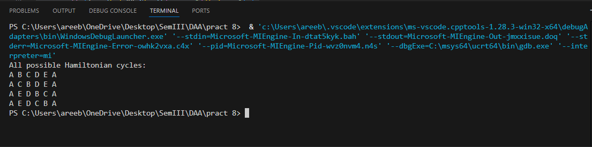

GFG problems

